Unit 4
Outcome 3
Structured Practical Investigation & Scientific poster
Design and undertake an investigation related to cellular processes and or biological change and continuity over time, and present methodologies, findings and conclusions in a scientific poster.
A structured scientific poster according to the VCAA template.
Not exceeding 1000 words

Antibiotics in Action:
Identify a suitable treatment for people infected with a food-borne pathogen.

Introduction:
Antiseptics are chemicals that kill or slow bacterial growth by destroying cell components, such as the cell wall and membrane. Their effects are general and often work against most bacteria. Antibiotics are chemicals that kill bacteria by more specific biochemical action on cells. Their effects are more specific to different types of bacteria.

The effect of antibacterial agents can be investigated by placing discs containing a chemical agent onto a bacterial lawn. A bacterial lawn is prepared by spreading a small amount of broth culture over the surface of an agar plate. This is performed with a strile swab or bacterial spreader. This method produces a uniform layer of bacterial growth over the whole plate, which, after a growth period, appears as an opaque ‘lawn’ of bacteria covering the agar. The paper discs have been soaked in the chemicals under investigation, such as antiseptrics, antibiotics or other chemicals. The chemocals diffuse into theagar around the disc. If it kills or slows bacterial growth, then a clear zone is seen around the disc. This is known as a disc diffusion assay. (Figure 1.)
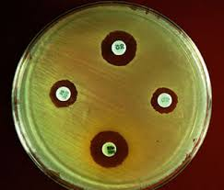

Figure 1. An example of a disc diffusion assay testing four substances
In this experiment you will investigate the effects of a range of antibiotics on one or more bacterial species.
You will learn about the technical methods and how to analyse results.

Materials (working in pairs)
- Nutrient agar plates
- Escherichia coli bacteria in broth culture
- Sterile swab
- Antibiotic discs (in sterile petri dish)
- Forceps
- Ethanol (small volume in a small beaker)
- Bunsen burner & matches
- 30-37C incubator

Method:
Step 1. Set up Bunsen burner station. Perform all bacterial work within about 30cm of Bunsen burner. The updraft created by the flame makes a working zone with reduced chance of contaminants falling onto your agar plate.

Step 2. Label the bottom (agar side) edge of the nutrient agar plate with your initals, the date and bacterial species. Draw lines to divide the plate into three segments.
Step 3. Spread a bacterial lawn (figure 2.) Dip the sterile swab into the bacterial broth and spread it uniformly over the surface of the agar; rotate the plate as you spread and go to the edges of the agar surface.
. 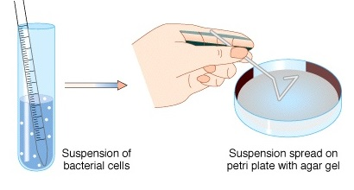

Step 4 Test three different antibiotics: you will be provided with forceps and small paper discs that are impregnated with antibiotic. Follow your teachers directions as to which antibiotics each group will test. Dip the tips of the forceps into ethanol, pass them through the flame so the ethanol lights and burns off. Carefully pick up each disc and place discs evenly spread on the surface of the agar. Place the letter down, in contact with the agar.

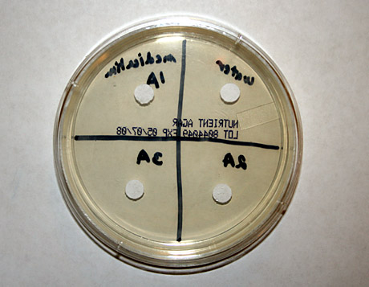

Step 5. In your logbook, record the colour and letter on each disc and the corresponding name of the antibiotic.

Step 6. Tape the lid onto the plate.
Step 7. Place in a 30-37C incubator overnight, with the bottom (agar side) upwards.

Experimental Questions:
Q1. Describe what you would expect to see in a bacterial lawn when the bacterium is not killed by the agents under investigation.

Q2. Describe what you would expect to see if the antibiotic is able to kill the bacterium.

Q3.Were controls included in your experiment. If so describe them. If not, explain the negative and positive controls that could/should be included.

Q4. Suggest a method for measuring the effect of each antibiotic so that you can record values and compare between antibiotics and compare to the other groups in your class.

Results
Step 8. Record your results and enter all details and images into your logbook.
- Photograph your plates using a smart phone
- Measure and record the Zone of Inhabitation (ZOI) as explained by your teacher.

Step 9. Collate all the classes’ data into a table.
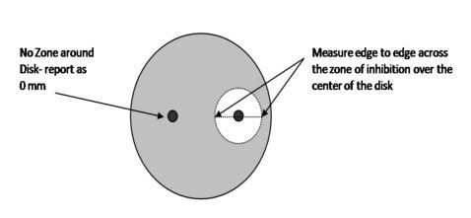

Analysis

Scientists use a measurement called the Zone of Inhabitation (ZOI) to compare the effectiveness of the antibacterial agents in agents in agar plate cultures. In standardised disc diffusion methods for testing antibiotics, a cut off value of 6mm is used to define when a bacterium is sensitive to an antibiotic and when it is resistant. If the ZOI is < 6mm, record the bacterium as resistant to the antibiotic. If the ZOI is 6mm or greater, record the bacterium as sensitive to the antibiotic.

Step 10. Make a table listing the antibiotic and whether the bacterium is resistant or sensitive.
Step 11. Construct a graph to represent your data. Discuss with your lab partner the most appropriate type of graph for this type of data.

Discussion Questions
Q5. Summarise the class results. Compare the effectiveness of the different antibiotics on the bacteria. If different bacteria were investigated, identify the antibiotics that were effective on all bacteria and those that had different effects.

Q6. Identify any inconsistencies and variability in the data; for example were replicates identical? Compare your own results with class averages.

Q7. Is the methodology in this experiment valid? Is there anything you should do to increase the validity?

Q8. Comment on whether the methodology used in this experiment is reliable. Is there anything you should do to improve the reliability?

Q9. Different types of antibiotics act by specific mechanisms. Therefore, their effectiveness varies against different groups of bacteria, such as gram positive and gram negative bacteria. Use your biology textbook, other books or online resources, to find the following information:
- The nature of the bacterium your group tested, such as normal habitat, its size and shape, the gram –staining properties (Is it Gram positive or gram negative) and what types of antibiotics are generally effective at killing it.
- Then search for information on the mechanism of each antibiotics tested (mechanism means how the antibiotic acts on the cell to stop growth) Based on the information you find, suggest some reasons for the effectiveness of the antibiotic you tested in this experiment.

Unit 4 Area of Study 3 Practical Investigation Overview

Step 1: Develop a research question and design a methodology to identify a suitable dose of antibiotic for treating patients with the food borne pathogen.
Research Question

Methodology: To determine the concentration of ampicillin that will inhibit growth of E.coli.

Teacher checkpoint

Step 2: Perform a standard experiment to determine the minimum inhibitory concentration of ampicillin for E.coli.
Record results in a table in your logbook, also collect class results.
Results

Teacher checkpoint

Step 3. Analyse class data
Produce an appropriate graph
Graph

Teacher checkpoint
Step 4. Prepare a poster to communicate the procedure and results of your practical investigation.
Use the standard conventions of scientific poster presentation to communicate your investigation. A template is provided to help you prepare the poster. Word limit 1000 words.
Include the following:
Title- your research question
Introduction, Aim & Hypothesis
Methodology
Results including Figures, Tables or Graphs
Discussion
References and Acknowledgements
Submit poster
Poster strengths & weaknesses
https://ugs.utexas.edu/our/poster/samples
this site was blocked though
http://www.posterpresentations.com/poster-templates-2015/classic/PosterPresentations.com-A3-Template-V5.pptx
Do’s & Don’ts
http://colinpurrington.com/tips/poster-design
